Date | January 12, 2021  Continuing Education Evaluation Form
Location | Live Webinar Presentation
CE Topic | Motivational Interviewing Basics
Speaker Name | Jacqueline Boyd

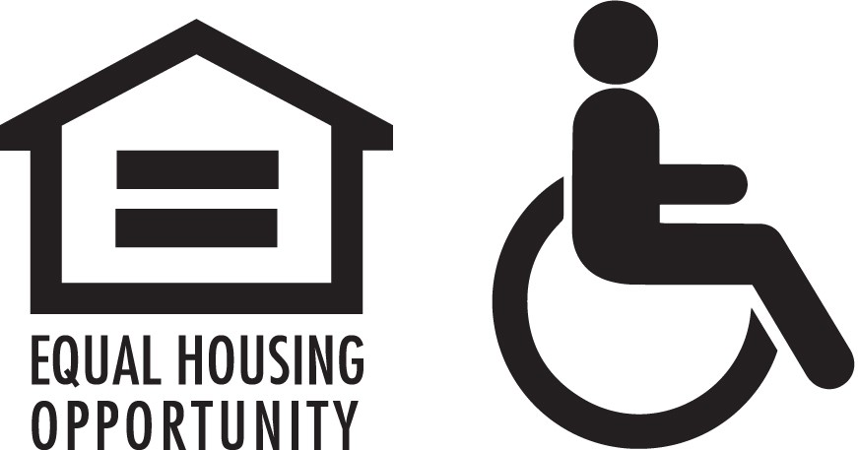
Participants must complete and sign this evaluation form to receive a CE certificate for this educational program.
Ratings
Knowledge of Subject Matter
Outstanding Good Adequate Needs improvement Poor N/A
Comments:
Quality of Presentation
Outstanding Good Adequate Needs improvement Poor N/A
Comments:
Content Relevance to my Practice
Outstanding Good Adequate Needs improvement Poor N/A
Comments:
Objectives Stated and Met
Outstanding Good Adequate Needs improvement Poor N/A
Comments:
Communication/Questions Addressed
Outstanding Good Adequate Needs improvement Poor N/A
Comments:
Length Appropriate for Content
Outstanding Good Adequate Needs improvement Poor N/A
Comments:
Overall Rating
Outstanding Good Adequate Needs improvement Poor N/A
Comments:
Evaluation

Additional Comments/Ways to Enhance Offering/Request for Future Topics

Name: Email:

I am a: SW RN LPN LCPC NHA Other: License #:

Thank you!
Phone #:

