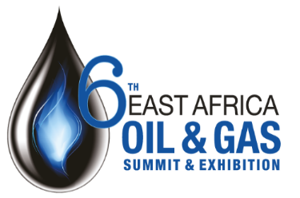

**3 Easy Ways to Register:  
Email:** Email a copy of this form to [info@eastafricanchamber.org](mailto:info@eastafricanchamber.org)   
**Book online:** [www.eventbank.com/event/19145/register/](http://www.eventbank.com/event/19145/register/)   
**Telephone:** EACCIA Secretariat +254 206 000 823

Delegate Booking Form for the 6th East Africa Oil & Gas Summit, 18-19 March 2020, InterContinental Hotel, Nairobi

Delegate 2  
Mr/Mrs/Ms/Miss Other…………………………………………..  
First name…………………………………………………………………  
Surname …………………………………………………………………..  
Job Title ……………………………………………………………………  
Email ……………………………………………………………………….  
Telephone number…………………………………………………..  
Mobile ……………………………………………………………………..

Delegate Fees

Early Rate valid before 31st January………….US $ 995

Standard Rate…….……………………………………US $1,395

*\*Delegate prices include access to all sessions, documentation and all networking functions and business matching*

Company contact details (for the invoice)

First name ……………………………………………………………….  
Last name ……………………………………………………………….  
Job title …………………………………………………………………..  
Email ………………………………………………………………………  
Company …………………………………………………………………  
Address 1 ……………..…………………………………………………  
Address 2 ……………..…………………………………………………  
Town ………………………………………………………………………  
City …………………………………………………………………………  
Country/State …………………………………………………………  
Postcode/Zip code ………………………………………………….  
VAT Number ……………………………………………………………

Delegate 3  
Mr/Mrs/Ms/Miss Other…………………………………………..  
First name…………………………………………………………………  
Surname …………………………………………………………………..  
Job Title ……………………………………………………………………  
Email ……………………………………………………………………….  
Telephone number…………………………………………………..  
Mobile ……………………………………………………………………..

Delegate 1

Mr/Mrs/Ms/Miss Other…………………………………………..  
First name…………………………………………………………………  
Surname …………………………………………………………………..  
Job Title ……………………………………………………………………  
Email ……………………………………………………………………….  
Telephone number…………………………………………………..  
Mobile ……………………………………………………………………..

Full payment must be made before the 6th East Africa Oil and Gas Summit (EAOGS) takes place. Once you have completed and returned this form you will be sent an invoice to be paid by bank transfer.

Total to pay US $……………………

I have read and agreed to the terms and conditions for delegate bookings and payment at the 6th East Africa Oil and Gas Summit (EAOGS)

Signature …………………………………………….………………………  
  
Date …….…………………………………………….……………………….