FOR IMMEDIATE RELEASE
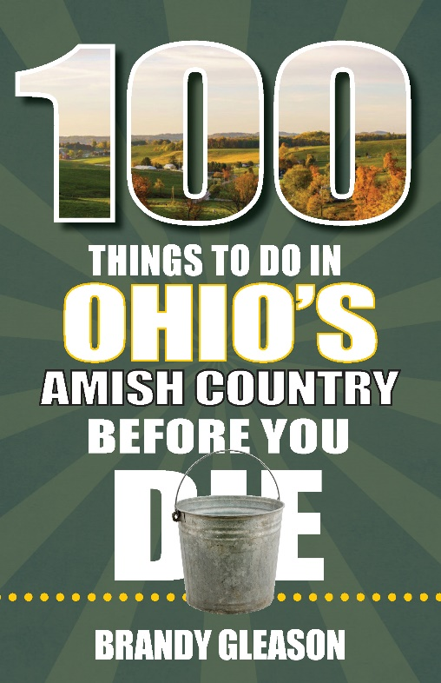 | UNCOVER THE BEST ATTRACTIONS PLUS HIDDEN GEMS IN THE AREA’S GO-TO GUIDE, 100 THINGS TO DO IN OHIO’S AMISH COUNTRY BEFORE YOU DIE  ST. LOUIS, MO—Reedy Press is pleased to announce the release of our newest guidebook, 100 Things to Do in Ohio’s Amish Country Before You Die, by Brandy Gleason.  Amish Country in the northeastern part of Ohio is America’s largest Amish community, where visitors are treated to the best of the best comfort food, deep-rooted historical locations, and opportunities to shop till you drop. There are so many things to do here that visitors would miss without a detailed guide.
Consider 100 Things to Do in Ohio’s Amish Country Before You Die your new guidebook to hand-picked locations curated from all the local favorites and hidden stops on the Amish Country backroads. Discover how the Amish came to this beautiful land of rolling hills, feed some animals on a wagon ride through a traditional farm, or have your taste buds burst with delight with some unique treats at one of the many bakeries.

Find ideas for exploring the outdoors, charming historic downtowns, and even some hidden gems. Don’t miss the insider tips on home-cooked food, gourmet dining in the woods, where to see Swiss cheese being made, or the finest furniture store to find that hand-crafted family heirloom to take home.

Whatever you are looking for in Amish Country, author Brandy Gleason provides a personal perspective into the community she has enjoyed visiting and exploring for over 35 years. She invites you to rejuvenate and slow down a little as you enjoy everything this peaceful-feeling community offers.

100 Things to Do in Ohio’s Amish Country Before You Die is available wherever books are sold.

Please contact Don Korte at dkorte@reedypress.com to arrange an interview or appearance.

Book Details: 100 Things to Do in Ohio’s Amish Country Before You Die – part of the 100 Things to Do Before You Die series, by Brandy Gleason, ISBN: 9781681063713, softcover, 5.5 x 8.5, 160 pages, $17.00

About the Author
Author Brandy Gleason, an Ohio native, travel expert at Travel Awaits, and a friend of travel brings her personal touch and perspective of her deep-rooted love of Amish country to life within these pages and shares all her favorites with you, it’s a gathering of everything she appreciates in one place. Also, one of the co-authors of Midwest Road Trip Adventures, Brandy has insight into all things Ohio and shares the best scenic road trips within her home state. She lives in Columbus with her big crazy family, a menagerie of farm animals, and the queen of the cabin (dog), Gracie.

Author Contact:
Brandy Gleason, gleasonfamilyadventure@gmail.com

Scheduled Events for 100 Things to Do in Ohio’s Amish Country Before You Die
It is advisable to check with the event venue for confirmation a few days ahead of a book signing or presentation.

Book Signing
Tuesday May 17, time TBD
Der Dutchman
4967 Walnut Street
Walnut Creek, OH 44687
330-893-2981
Free and open to the public

Book Signing
Wednesday, May 27 time TBD
Mohican State Park Lodge
1098 Ashland County Road
Perrysville, OH 44864
419-938-5411
Free and open to the public

Book Signing
Wednesday through Saturday, June 1-4 times TBD
Walnut Creek Flea Market
1900 OH-39
Sugarcreek, OH 44681
330-852-0181
Free and open to the public

Book Signing
Saturday, July 9 time TBD
Tis’ the Season
4363 OH-39
Millersburg, OH 44654
330-893-3604
Free and open to the public

TALKING POINTS FROM THE BOOK:
● Brandy Gleason has written two books and a plethora of freelance articles about Ohio and its many travel treasures. Her well-rounded knowledge of Ohio’s Amish Country and authentic perspective will give you an insider’s look at the history, attractions, and all the best Amish eateries.
● Visitors love coming to this beautiful slice of Ohio and it is no surprise once they get to Amish country they wonder how this wonderful place came to be. Get a glimpse into the Amish, Mennonite, and Hutterite history at the cultural museum.
● If you love food, Amish Country is the place to be. With so many options you’ll want to know which places that suit your palate. From down-home Amish-style meals to upscale fine dining, Brandy Gleason will guide you to all the best places.
● Outdoor adventures surround the area and while many come to shop and eat, you can get your exploration steps in too. Find the best trails to hike, visitor centers for information, places to get out on the water in kayaks or rafts, or zipline through the sky.
● If you have wondered where you can eat in an Amish home you can find the answers within the pages of 100 Things to Do in Ohio’s Amish Country Before You Die. Hop onboard a guided back road country tour and have lunch in a real Amish home. You’ll come as a guest and leave as a friend.
● Ohio’s Amish Country rolls up the sidewalks around 5:00 PM, but you can still find things to do at one of the local theaters. Choose from side-splitting hilarity at the Amish Country Theatre or one of the Amish-themed shows at Ohio Star Theater.
● Drive from village to village and stop in all the Historic Downtowns to do some shopping or grab a cup of coffee as you road trip through the gorgeous rolling hill and countryside. Brandy Gleason gives you all the places to stop and enjoy.
● Hospitality and friendly “how are you’s?” are the heartbeat of this community, you’ll want to sit in a rocking chair on the porch of the Der Dutchman, or take a ride in an Amish buggy before you leave.
● Amish Bent and Dent stores are known as Amish Wal-Marts but you’ll never know what you will find in one of these one-of-a-kind stops.

###

