Walking directions from the Hilton to the National Museum of the American Indian
14min, 0.7 miles Via 9th St SW and Jefferson Drive SW
Start Hilton Washington DC National Mall, The Wharf, 480 L'Enfant Plaza, SW, Washington, DC
- Head north on 9th St SW toward C St SW, 0.3 mi
- Turn right onto Independence Ave SW, 138 ft
- Turn left onto path, 49 ft
- Turn right, then immediately turn left onto 7th St SW, 0.2 mi
- Turn right onto Jefferson Dr SW, 0.2 mi
- Turn right onto path, 259 ft
- Arrive at your destination on the right
(The last intersection before your destination is Jefferson Dr SW. If you reach Maryland Ave SW, you've gone too far).
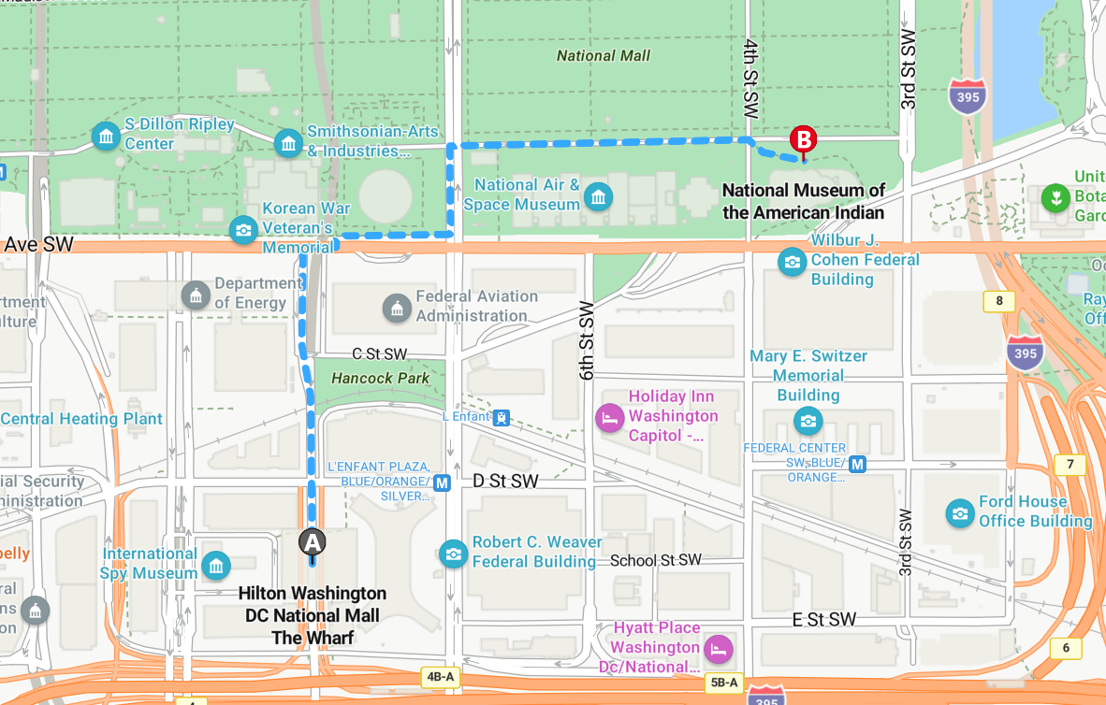
Finish National Museum of the American Indian, 300 Maryland Ave., NE, Washington, DC

