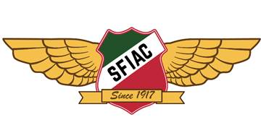

2022 Membership Renewal

Membership dues are more important than ever before to continue funding the mission of the club. Dues fund celebrations and promotion of Italian culture, athletics, and brotherhood. They keep our traditions and create new ones like lighting the club, church, and park in the Tricolore over Heritage Weekend. They keep the soul of our beloved North Beach Italian in the face of unrelenting change.

If it is easier to transition to a monthly subscription do not hesitate to ask. Our annual dues of $444 for regular members, $120 for associate and $145 for lifetime remain the best value in town and we hope that you continue supporting this unique institution and Italian heart of the Bay Area.

Regular member dues $444
Associate member dues $120
Lifetime member dues remain at $145.
Member dues and fees cover only 25% of your Club's operating expenses. If you wish to make a voluntary contribution to the SFIAC Foundation, General Operating Fund or Sports Fund for 2022, please make note, below or donate online.
Payment Options
Mail your check payable to: San Francisco Italian Athletic Club or SFIAC.
Mail your check or credit card information to:
San Francisco Italian Athletic Club
P.O. Box 330154
San Francisco, CA 94133
NOTE: Club dues and fees are payable now and are past due afterJanuary 31, 2022.
CREDIT CARD INFORMATION (if paying by credit card). We accept Visa, Mastercard, American Express and Discover Card.
Name: _____________________________________
Please provide your email address: ____________________________ll_____________
Card Number:______________________________________ (16 digits)
Expiration Date:__________ 3 digit Code: _________ Signature:_____________________________
Dues or Fees amount $______________ Donation $______________
TOTAL PAID $______________

