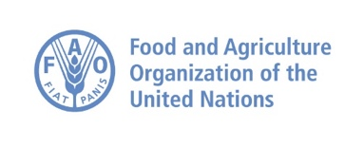****

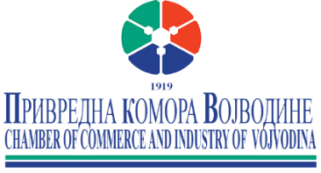

**PRESENTATION: GUIDE FOR THE EXPORT OF FRUIT**

**AND VEGETABLES TO THE UK MARKET**

Tuesday, February 20, 2024

12.00 CET

Chamber of Commerce and Industry of Vojvodina

Novi Sad, Braće Popović 5

Master Centre, III floor

**AGENDA**

11.45 – 12.00 Press statements**: Mr Bosko Vucurevic** and **HE. Edward Ferguson**

12.00 – 12.20 Welcome speeches

**Mr Bosko Vucurevi**c,

President of the Chamber of Commerce and Industry of Vojvodina

**H.E. Mr. Edward Ferguson**

Ambassador, British Embassy Belgrade, Serbia

12.20 – 12.45 Presentation of “**Guide for the export of fruit and vegetables to the UK market**”

by British-Serbian Chamber of Commerce

**Ms. Jadranka Dervisevic Kitaric**,

BSCC Executive Director

12.45 – 13.00 Discussion

13.00 - 14.00 Cocktail/networking

***

Working language: English/Serbian with simultaneous translation.

Moderator: Milan Stojanov, CCI Vojvodina

YouTube link: <https://youtube.com/live/boxSA6z-cs8?feature=share>

