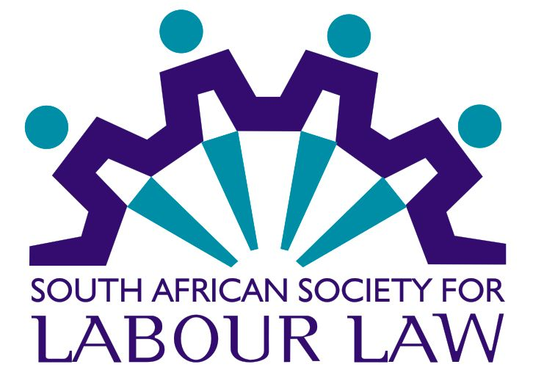

AGENDA OF THE 25th ANNUAL GENERAL MEETING OF
THE GAUTENG CHAPTER OF THE SOUTH AFRICAN SOCIETY FOR LABOUR LAW
Via WEBINAR ON ZOOM
ON WEDNESDAY 1st JUNE 2022 AT 16H00

- Confirmation of the Minutes of the General Meeting 1 June 2021

- Annual Report of the Society’s Affairs and the Income Statement of the Chapter – March 2021 to February 2022

- Election of the Chapter President and Vice President

- Election of Committee members

- General and thanks

Seminar Topic | Revisiting the principles relating to proper consultation in mass retrenchment, as well as the application of section 189A(13), in the light of the recent judgment in Solidarity obo Members v Barloworld Equipment Southern Africa and Others (CCT 102/21) [2022] ZACC 15 (6 May 2022).

*****************

