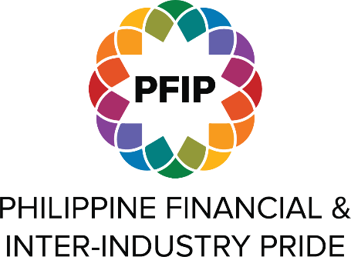 | PHILIPPINE BAHAGHARI AWARDS 2022
 | PRIDE COMPANY OF THE YEAR AWARD
ABOUT PFIP
The Philippine Financial & Inter-Industry Pride (PFIP) is a collaborative, voluntary, and non-profit community of practice composed of dedicated representatives from LGBT+ employee resource groups and/or human resource/diversity teams of private firms in the Philippines.

Established in 2013, PFIP is the Leading Voice and Champion of LGBT+ Workplace Inclusion that serves as an advisory board for Pride networks, provides professional development opportunities for self-identifying LBGT+ individuals, and promotes inclusive practices and policies within organizations. In 2021 PFIP became an Honoree at the Out & Equal Workplace Summit

ABOUT THIS AWARD
Philippine LGBT+ Workplace Inclusion Awards aims to recognize Individuals, Leaders, and Organizations that have shown exceptional effort in advancing LGBT+ Workplace Inclusion in the Philippines.

The Pride Company of the Year Award is given to the company that has demonstrated consistent leadership and commitment in LGBT+ inclusion in an out of the workplace. The following are key requirements and criteria for this award:

- CRITERIA 1: Strategic Intent and Impact - An LGBT+ inclusion strategy with clear measurable outcomes has been defined for the organization and evidence of how this has benefited employees, contributed to the business, or helped improved the organization over-all is available.
- CRITERIA 2: Leadership Excellence – The firms has demonstrated and can provide evidence of any key accomplishment, pioneering work, or outstanding contribution made by the organization to advance LGBT+ inclusion in and out of the workplace.
- CRITERIA 3: Consistency and Sustainability – The firm can demonstrate and provide evidence that their LGBT+ inclusion strategy is systemic and sustainable.
- Company must be a PFIP member firm in good standing
- Only significant work or accomplishments within the assessed calendar year July of previous year to June of current year will be considered for this award

ABOUT THIS FORM
This document is an offline version of the nomination form to help companies prepare their entries before actual submission. Once ready, please submit your official entries through this link on or before August 22, 2022, 5:00 PM PHT

PART 1 – GENERAL INFORMATION (Nominee)

Company Name
Company Size | - 1 to 1,000 employees  - 1,001 to 5,000 employees  - 5,001 to 10,000 employees  - 10,001 to 20,000 employees  - Greater than 20,000 employees
Industry
Company Address
HR Lead or D&I Manager Name
Official Job Title
Email Address
Mobile Number

PART 1.2 – GENERAL INFORMATION (Nominator)
Name of the Nominator
Official Role Title
Company/Organization Name
Email Address
Mobile Number

PART 2 – AWARD INFORMATION

STRATEGIC INTENT AND IMPACT
Describe the LGBT+ strategy of the organization, how this has benefited employees, contributed to the business strategy, and/or helped improve the organization over-all. (500 word limit).

GUIDE QUESTIONS:
- How is SOGIE inclusion embedded in your broader business and DEI strategy?
- What are some of your key success measures and how have you achieved them?
- What are the key focus areas of your LGBT+ strategy and how does this help your organization over-all?

LEADERSHIP EXCELLENCE
Describe any key accomplishments, pioneering work, or outstanding contribution made by the organization to advance LGBT+ inclusion in and out of the workplace. (500 word limit).

GUIDE QUESTIONS:
- What are some LGBT-specific programs, projects, and other initiatives that you consider as best practices (e.g. toolkits, innovative projects/programs?)
- How does your organization promote LGBT+ inclusion in the areas of hiring, retention, and career development
- In the absence of state-mandated benefits, how does your organization ensure equitable compensation and benefits for its LGBT+ employees and their families?

CONSISTENCY AND SUSTAINABILITY
Describe any strategy employed by the organization to make its LGBT+ inclusion efforts systemic and sustainable. (500 word limit)

GUIDE QUESTIONS:
- How has your organization institutionalized LGBT+ programs, initiatives, etc?
- How are employees and managers meaningfully engaged in inclusion strategies and practices and how are these embedded in their work or the environment?

PART 3 – ATTACHMENT

Please provide any supporting or reference material as evidence of your work. You may also use your attachment to highlight any additional work you are doing in the LGBT+ space. Please submit file in PDF format not exceeding 10 MB.

Attachment

