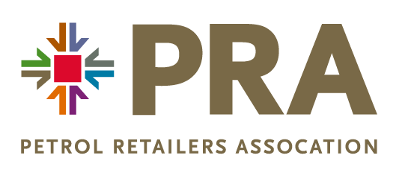

PRA FORECOURT ROADSHOWS – TERMS & CONDITIONS

The Petrol Retailers Association (the PRA) acknowledge that in return for the payment of the agreed fee paid by the Exhibitor for attendance at The Forecourt Roadshows events in 2023 the PRA agree to provide the Exhibitor with:
- A stand size no bigger than 3 x 2 metres (unless agreed prior to event),
- The ability to advertise your business within the allocated stand space,
- Entry for Exhibitor representatives,
- Catering provisions of lunch and tea/coffee for all Exhibitor representatives on the event day,
- Right to promote the Exhibitor business to Roadshow attendees,
- Access to the venue as per build up instructions supplied in advance of the event to facilitate set up,
- Post event, a list of attendees within 7 working days.

In return the Exhibitor agrees to:
- Inform the PRA of details of the Exhibitor representative no less than 24 hours prior to the start of the Roadshow,
- Undertake and keep in full force any policies of insurances as are necessary,
- Ensure equipment brought to the venue is fit for purpose and in good working order and in compliance with any relevant regulatory frameworks,
- Raise concerns and any complaints with a representative of the PRA within a timely manner.

The PRA are not liable for any loss or damage to any equipment, object or property which you, your sub-contractors or agents, your invitees, employees or the public or any other third party may incur or sustain.
Right to refunds – if the Exhibitor provides to the PRA written notice of not less than 14 days that they wish to cancel their attendance then the Exhibitor will at the discretion of the PRA be able to claim a refund of 50% of the fee paid.
Should the Exhibitor have any queries then they should address these to:
Steve.coombe@rmif.co.uk Tel: 07831 373205

