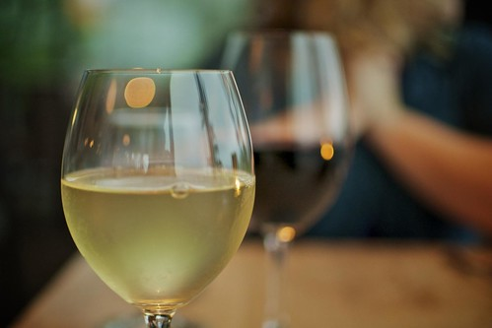

Get Out and About on Tuesday Evening
401 Prime (Luxury Modern Steakhouse)
Annie Bailey’s (Irish Pub)
Atlanta Rooftop Lounge (small casual menu)
Belvedere Inn (great food and martinni’s)
Bistro Barberet & Bakery (French)
Conestoga Restaurant (American/Greek, appetizers/entrees/sandwiches, outdoor dining)
C’est La Vie (casual dining)
Greenfield Restaurant (former White House Chef/author/great food and bar, patio dining)
Horse Inn (casual with award winning cocktails)
Josephine’s Downtown (French)
Lancaster Brewing (hot spot for local beer, pub fare, outdoor dining)
Lombardo’s (amazing Italian food)
Luca (old country Italian)
Max’s Eatery (modern diner experience with a full bar)
Old San Juan Latin Cuisine & Rum Bar (Puerto Rican Fare)
Plough (right inside the Marriott, fresh local ingredients, casual)
Queen Street Bistro (Vast food options)
Quips Pub (English/Irish fare)
Root (Vegan)
Spring House Brewery’s Taproom (sandwiches, wings, pizza)
The Exchange (small plates, wood fired pizza)
The Imperial (Culinary masterpieces)
The Pressroom (American fare, local organic ingredients)
Yorgo’s/Kefi/Little Mykonos (Casual, Greek, Lounge)

