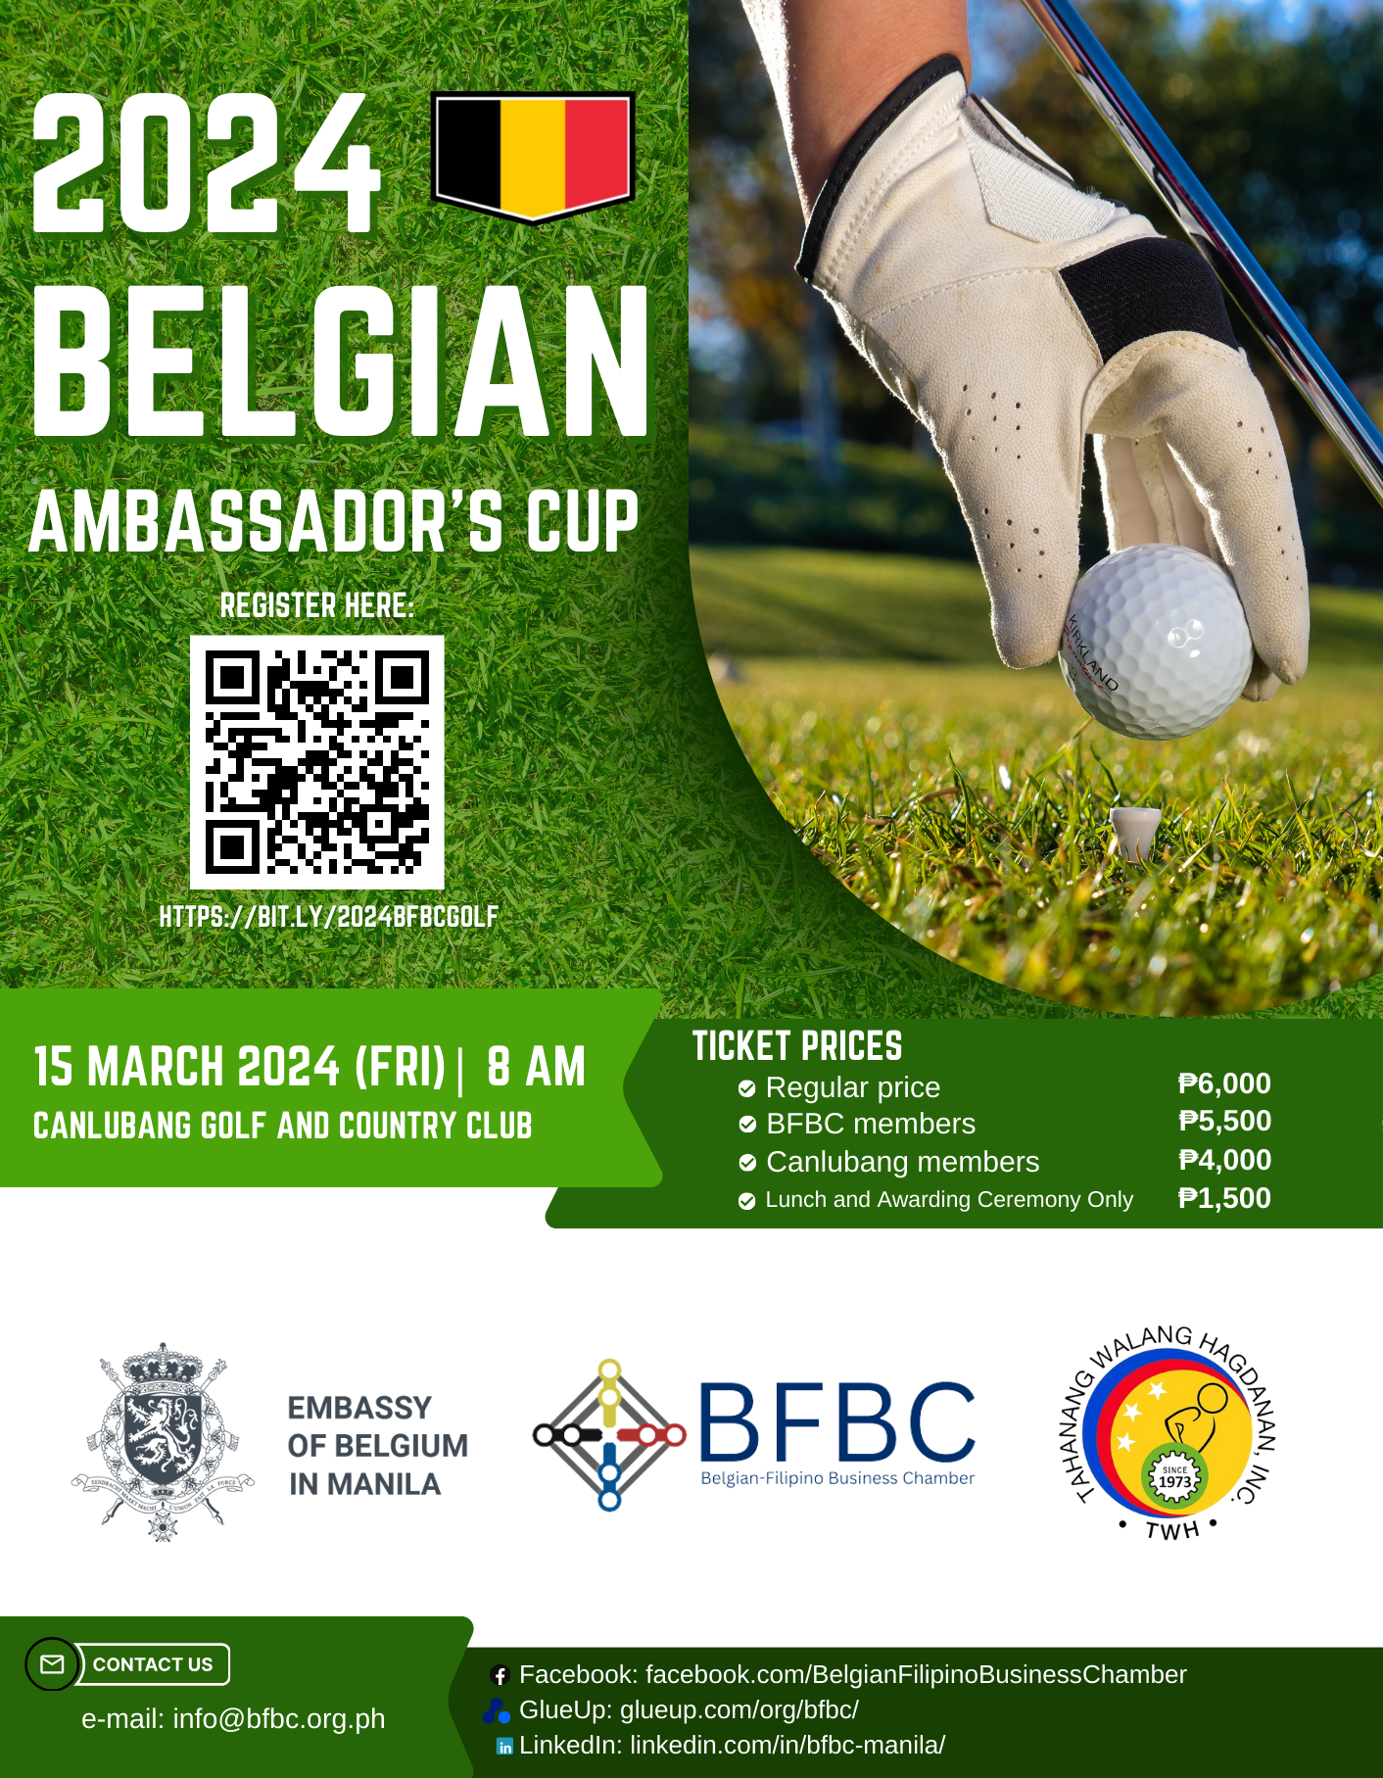

2024 BELGIAN AMBASSADOR’S CUP – SPONSORSHIP FORM
I wish to contribute to the 2024 Belgian Ambassador’s Cup fund as a (tick at least one box below):

A. EVENT SPONSORS
1.  Diamond Sponsor ₱ 150,000 cash
2.  Platinum Sponsor ₱ 100,000 cash
-  Gold Sponsor ₱ 50,000 cash
-  Silver Sponsor ₱ 30,000 cash

B. TOURNAMENT SPONSORS
-  Hole-in-one Sponsor ₱ 100,000 equivalent or Car
-  Golf Cart Sponsor ₱ 50,000 cash
-  Nearest to the Pin Sponsor ₱ 30,000 cash or equivalent
-  Longest Drive Sponsor ₱ 30,000 cash or equivalent

C. AWARDING CEREMONY SPONSORS
-  Merchandise Sponsor ₱ 50,000 worth of event merch
-  Lunch Sponsor ₱ 50,000 worth of lunch/cash
-  Raffle Sponsor ₱ 5,000 worth of items/cash

Please fill in the below information for us to coordinate with you and give you the appropriate recognition:

Name | ______________________________________
Address | ______________________________________
E-mail | ______________________________________
Mobile | ______________________________________
Company (if corporate donor) ______________________________________

BFBC’s Bank of the Philippine Islands (BPI) Account
Account Name: Belgian-Filipino Business Club
Account No.: 0081-0582-53

The amount stated above has been paid to the BFBC’s BPI Account on (date) _______________ for contribution to the 2024 Belgian Ambassador's Cup.

Signature over printed name: ______________________________________
Date: ______________________________________

Click here for the fillable sponsorship form: https://bit.ly/2024GolfFillableForm
Please complete and send this form to Belgian-Filipino Business Chamber at info@bfbc.org.ph

