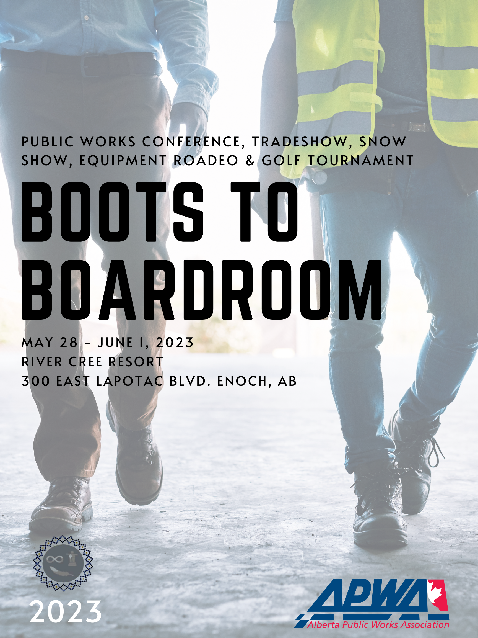

**Public Works Conference, Tradeshow, Snow Show, Equipment Roadeo & Golf Tournament**

**Boots to Boardroom**

**EARLY BIRD PRICING**

**Full Conference Registration   
Delegate:** $695

**Emerging Leaders** (35 & under)**:** $595

***CEUS*** - ***APWA 30 / AEP*** *(in review)*

**ONE Day Attendance**

Tuesday: $445

Wednesday: $345

**Public Works Administrative Assistant Workshop - $395**

*Includes Monday Meet & Greet and Tuesday Keynote, Sessions, and Tradeshow Supper*

**Pre-Conference Workshops**Water Course .6 AEP CEU’s - $250

Legal Issues and FOIP Responsibilities – AM $250

Myth of Multitasking - Michelle Cederberg – PM $250

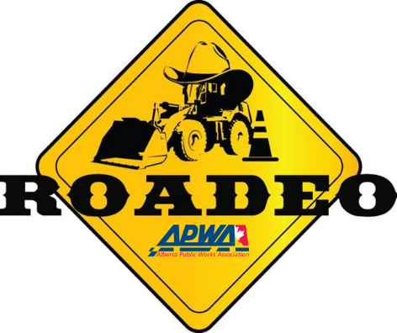**24th Annual Equipment & Snow Roadeo Thursday June 1st**

**Each event is $175 (add $500 for full conference or $275 for Wednesday only)**

This year we are combining our Equipment Roadeo and Conference. Compete or come cheer on your favourite operator. Events include

* Motor Grader
* Wheel Loader
* Single-axle Truck
* Tractor Backhoe
* Skid Steer
* Truck Plow

Includes Networking dinner event Wednesday May 31st  with entertainer Herb Dixon, competition June 1st. For full information on the events head to the website.

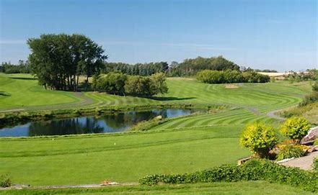

**The Golf Tournament is May 28th at 2:00pm**

**$150**

**At The Ranch Golf and Country Club,**

**9574 Pinchback Rd**Join us for a best ball golf tournament at The Ranch Golf and Country Club. Enter as an individual or as a team. Price includes 18 holes of golf, bucket of warm up balls, shared cart, dinner and prizes.

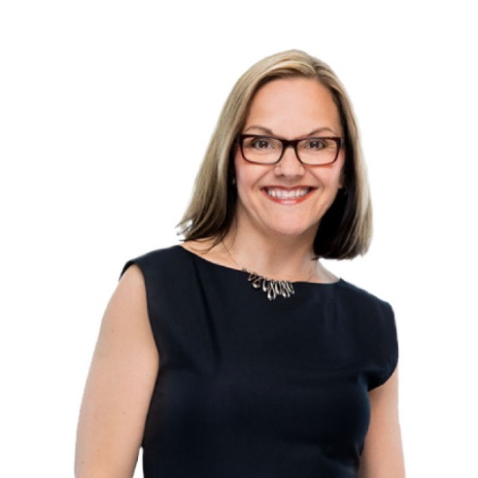

Schedule

Sunday May 28

***2:30 pm*** *Golf Tournament at The Ranch Golf & Country Club*

Monday May 29

**Pre – Conference Courses & Networking**

* *AM - Legal Issues and FOIP Responsibilities*
* *PM - Myth of Multitasking*

Tuesday May 30

**7:30 AM** *Breakfast*

**9:00 AM** *Keynote*

**10 AM** *Coffee Break*

**10:15 AM – 3 PM** *Technical Sessions and Admin Workshop*

**12 – 1 PM** *Lunch Break*

**3 PM** *Tradeshow opens*

**3 – 4 PM** *Technical Exhibitor session on Stage & Live Demo*

**4 – 6 pm** *Happy Hour*

**6 – 7 pm** *Supper & Prizes*

**Free Evening**

Wednesday May 31

**8:30 – 11:30 AM** *AGM & Sessions in Enoch Grand Ballroom*

**11:30 AM – 3 PM** *Dedicated Trade Show*

**12 PM** *Lunch Break*

**1 – 3 PM** *Exhibitor Sessions on Stage & Live Demo*

**3 PM** *Tradeshow Closes*

**3 – 4 PM** *Roundtables in Enoch Grand Ballroom*

**4 PM***Awards Ceremony*

**6 PM** *Roadeo Participant Social*

**8 PM** *Herb Dixon Comedian*



Meet Our Keynote

**Michelle Cederberg, CSP**

For over 17 years, Health and Productivity Expert Michelle Cederberg has captivated audiences across North America with her empowering and humorous messages about how to set chase-worthy goals, get energized for success, and live a bigger life.

An in-demand speaker, author, coach and consultant, she believes that personal and professional success is directly influenced by how well we harness the physical, mental and emotional capacity we each have within us. She helps people boost that capacity, so they gain clarity, build confidence, and get the discipline to create the life and career they want. And she’s taken the virtual world by storm!

She holds a Masters in Kinesiology, a BA in Psychology, a specialization in Health and Exercise Psychology, is a Certified Speaking Professional, a Certified Exercise Physiologist, and a High-Performance Coach. She truly combines mind, body and practicality to empower change.

**Michelle is the author of three books. Her latest book, The Success-Energy Equation, debuted as a bestseller!**

Annual Equipment & Snow Roadeo

**Networking Night - Wednesday**

Join us at The River Cree, Enoch Ballroom, from 6:00pm -9:00pm, for a night of fun, networking and entertainment hosted by Comedian Herb Dixon. This night is a great opportunity to meet teams from across the province and to support the suppliers who help make the Roadeo a success!

**Roadeo Day - Thursday:**

8:00 AM Volunteers and Judges Orientation

8:00 – 8:45 AM Operator Registration

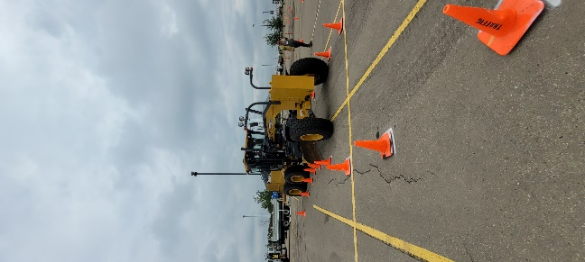 8:45 – 8:55 AM Course Walk-through

9:00 AM – 3:00 PM Events

11:30 AM Lunch

3:00 – 4:00 PM Awards

**Pre – Conference Workshops**

**Disinfection: The Whole Story – Kurt Stogrin**

This course will lead you through the history of disinfection, importance of disinfection, and specific types of disinfection such as sodium hypochlorite, gaseous chlorine, and UV disinfection, as well as some operator math.

It will last a total of 6 hours.

0-6 CEU’s AEP

6 CEU’s PWS

**Legal Issues and FOIP Responsibilities**

*How to protect information, your municipality and yourself*

* Municipal Liability

Ways to protect your municipality from that liability. We will review the law relating to negligence in municipal operations like snow clearing, as well as occupier’s liability for injuries taking place on municipal property. We will also address the various statutory protections from liability afforded to municipalities (and municipal elected officials and employees), as well as discussing ways of seeking to reduce the risk of liability, including through the development of policies or the use of waivers.

* Dealing with Difficult Residents & FOIP

**Myth of Multitasking – Michelle Cederberg**

*How to find focus in a distracted world.*

In an era of 24/7-connectedness and ‘nose to the grind-stone’ ideologies, multitasking has become something of a workplace badge of honour. In fact, it’s often heralded as a ‘work skill’ in interviews and on resumes. But is it really?

And the pandemic only added to our overwhelm because of online and hybrid options that have stuck around. With the addition of technology and reduction of boundaries between work and life, we’re more distracted than ever, and it means that multitasking feels more like a necessity that a choice. How else will we get it all done? The truth is that multitasking doesn’t make us more productive; in fact the exact opposite is true.

In this eye-opening session, you will:

* Explore the signs of ‘auto-pilot living’, why it happens, and how to get off it
* Look at how multitasking impacts productivity, what’s happening in your brain when you take on too much, and how it hinders learning and memory
* Discuss simple strategies to push aside distractions and be more mindful and focused when it matters most.

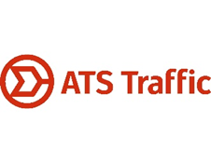**Technical Program**

**Tuesday May 30**

7:30 AM Registration and breakfast

9:00 AM Keynote Michelle Cederberg sponsored by:

10 – 10:30 AM Coffee Break

10:30 – 11:15 AM Technical Presentations

* ROW – Issues & New Challenges in a Changing World
* Invasive Species 101
* A Day in the Life of Fred the Municipal Fleet Manager

11:20 AM – 12:00 PM Technical Presentations

* Red Deer’s Approach to ROW Management
* A Collaborative Research-Based Approach to Improving Urban Tree Survivorship
* Challenges & Opportunities in Municipalities Pavement Maintenances

12:00 – 1:00 PM Lunch Break

1:15 – 1:45 PM Technical Presentation

* Update in the Damage Prevention Process
* City’s Urban Forrest Asset Management Plan
* Graffiti

2:00 – 2:45 PM Technical Presentation

* Update in the Damage Prevention Process Continued
* City of Edmonton Tree Inventory & Work Flow
* Weather Tools to Help You Make Decisions

3:00 – 4:00 PM Technical Session & Live Demos

4:00 – 6:00 PM Happy Hour

6:00 – 7:00 PM Supper & Prizes

This is a free evening

**Wednesday May 31**

7:30 – 8:30 AM Breakfast

8:30 AM AGM

9:00 AM Utility Safety Partners

9:15 AM Hiring & Retaining for Strong Culture

10:00 AM Coffee Break

10:15 AM OHS Code 2023 Updates

11:15 AM STARS

11:30 AM – 3:00 PM Tradeshow: Live Demos & Technical Training on Stage. Includes Lunch.

* 1:00 PM Traffic & Collision Data
* 1:30 PM Embracing Winter Maintenance Liquids

3:15 – 4:00 PM Roundtable/Bear Pit Session

* Snowfighters/Transportation
* Managers
* Parks

4:00 PM Annual Awards & Cocktail Reception

6:00 PM Roadeo Participants Dinner & Entertainment

8:00 PM Herb Dixon Comedian

*Roadeo Setup Ongoing Throughout the Day*

**Thank you to our Platinum Sponsors**



**Thank you to our Silver Sponsors**



Friends of APWA AB Chapter