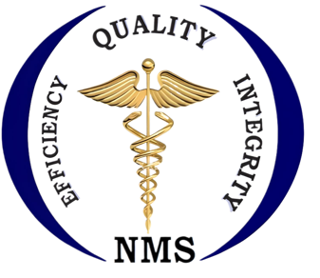**Namibia Medical Society**

**Agenda**

**of the**

**2024 Annual General Meeting (AGM)**

Date : 7 September 2024

Time: 15h45 -18h15 (2h30minutes)

Venue: Swakopmund

Attendees: All NMS Members in good standing

1. **Verification of Members & Registration of attendance**
2. **Apologies**
3. **Adoption of the Agenda**
4. **Reading of the minutes of the 2023 Annual General Meeting**
   1. Adoption of the minutes
   2. Feedback & Discussion on matters arising from the minutes
5. **New Matters**
   1. ***Chairman’s report & Discussions***
   2. ***Treasurer’s report & Discussions***
   3. ***Ammendments to The NMS Constitution***
   4. ***The Draft 3-Year NMS General Work Plan***
   5. ***Long-term Funding Strategy: Establishment of the NMS Savings & Credit Co-operative (NMS SACCO)***
   6. ***The Medical Internship Program & Medical Intern’s Working Conditions***
6. **Any other business**
   1. Membership fees & related matters
   2. Nominations and secondment of NMS Members to other bodies
   3. …………
7. **Closing Remarks**
8. **Date of the Next Meeting**

*Version: 26 August 2024*

*Final Submission of items from members under 6. Any other business is Thursday 29 August 2024 @17H00*

*Submissions can be made to:* [*nms@iway.na*](mailto:nms@iway.na) *or* [*namibiamedicalsocietyNMS@gmail.com*](mailto:namibiamedicalsocietyNMS@gmail.com)