Optional Activities to check out in the area:
- Georgia Museum of Art – Tuesday 10 a – 5 pm, Wednesday 10 a – 5 pm, Thursday 10 a – 9 pm
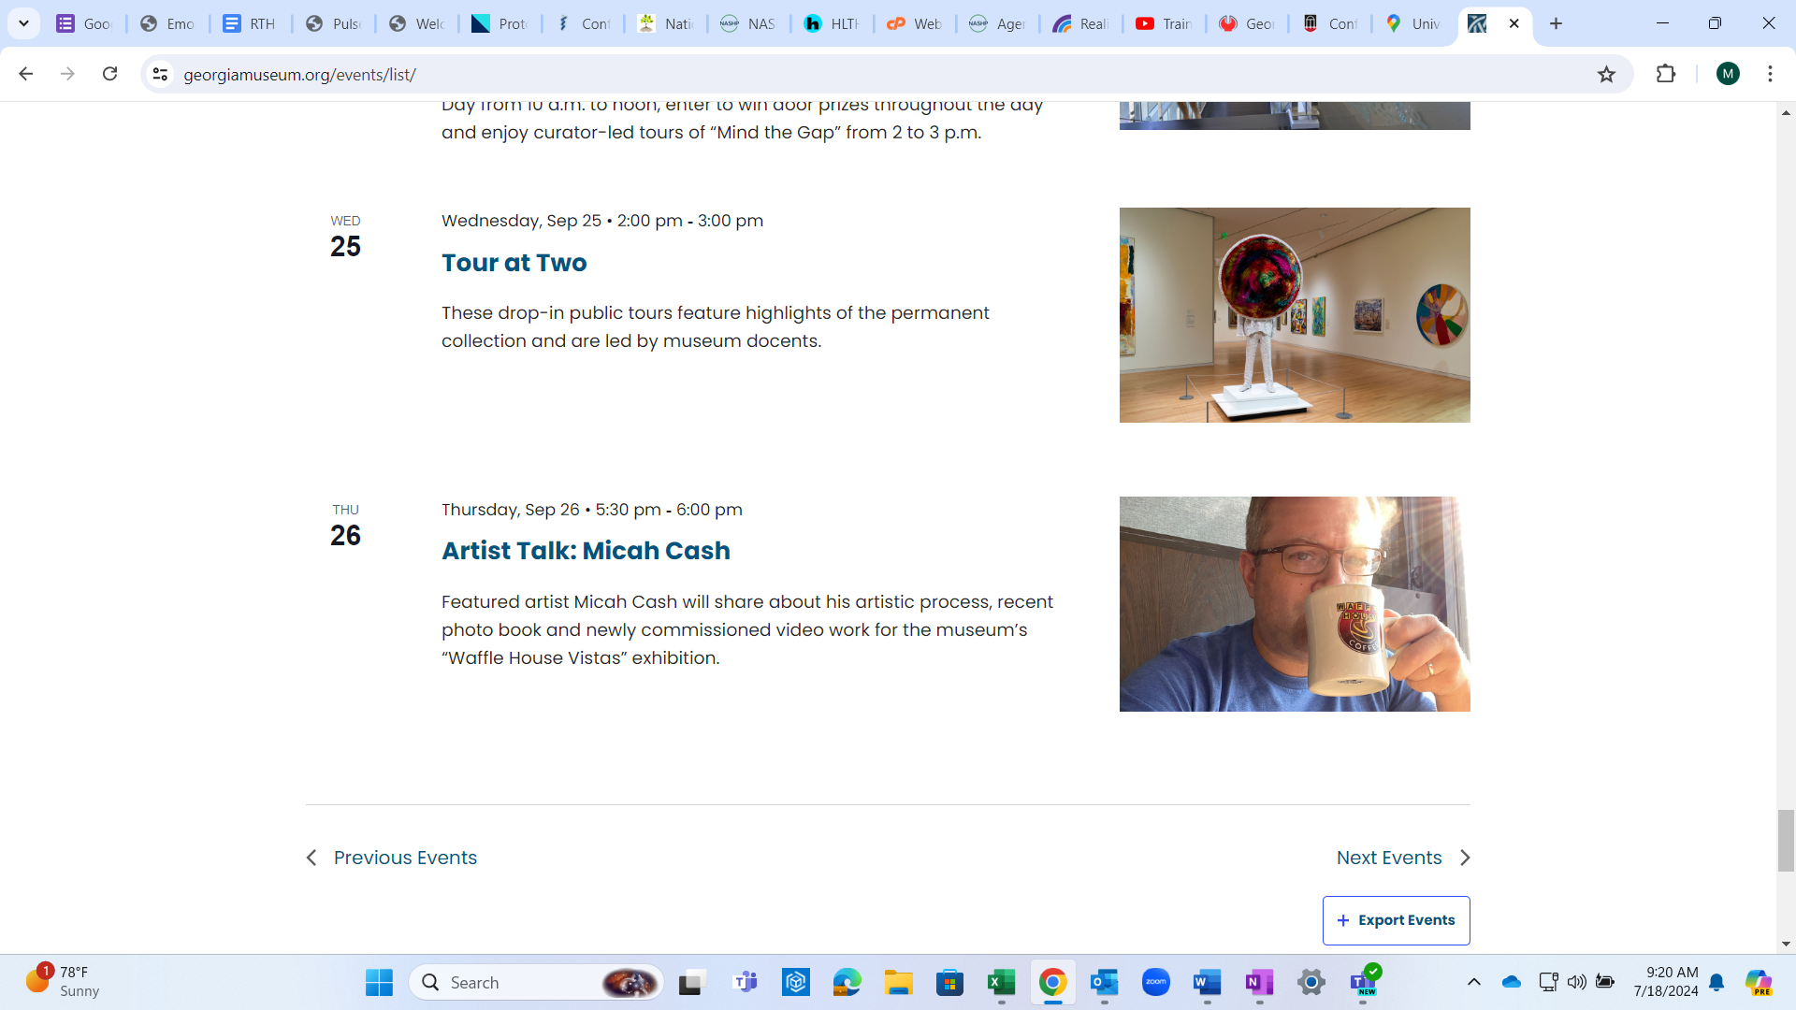
- Sandy Creek Nature Center – Tues – Sat 8:30 A – 5:30 P
Trails open Sunrise to Sunset
The property features 225 acres of woodlands and wetlands with over 4 miles of trails, including an ADA interpretive trail and a connection to the North Oconee River Greenway
Free Admission
naturecenter@accgov.com
205 Old Commerce Rd. Athens, GA 30607

"Adult Line Dancing" at Rocksprings Park

Tuesday, September 24, 2024
Line dancing is a great way to stay active and keep your body moving! Rocksprings Park is hosting a class for active adults to come together once a week to learn and practice a new dance each month.
Ages: 18 and older
Date: Tuesday, September 24
Fee: $1 per person
Location: Rocksprings Park, 706-613-358
Registration: Register online
291 Henderson Ext.
Athens, GA 30606

"Scissors, Paper, Art Works by Jack Burk and Claire Clements" Exhibition at Lyndon House Arts Center

Saturday, July 6, 2024 – October 5, 2024
The Lyndon House Arts Center is pleased to announce "Scissors, Paper, Art, works by Jack Burk and Claire Clements" on view from July 6 – October 5, 2024.
"Scissors, Paper, Art" is an exhibit of collaged works by Jack Burk and Claire Clements. Utilizing paper, painting, and drawing, the pieces sing with the vibrancy of the natural world. Plants and flowers are present in all of the images, expressing a lushness that connects material and subject matter. Central to Clement’s technique is the use of silhouettes and flat planes of color, while Burk explores texture and materiality.
A resident of Athens, GA, Iowa-transplant Burk is a former public school art educator who has shown widely across the city. Clements is an associate professor emerita of the University of Georgia College of Education, where she taught for almost 20 years. Both Clements and Burk are active members of the local Plein Aire Painters group, which Clements helped found
This exhibition was organized as a result of the artists submitting an Exhibition Proposal through the Lyndon House Arts Center's website: www.accgov.com/lyndonhouse. There is an ongoing call for artists and community members are encouraged to apply.
All exhibitions at Lyndon House Arts Center are free of charge and open to the public. Exhibitions are on view during regular gallery hours Tuesday and Thursday 10:00 a.m. – 8:00 p.m., Wednesday, Friday and Saturday 10:00 a.m. – 5:00 p.m.
Lyndon House Arts Center
211 Hoyt Street
Athens, GA 30601

"Works by Amiri Farris" Exhibition at Lyndon House Arts Center

Saturday, July 6, 2024 – October 5, 2024
The Lyndon House Arts Center is pleased to announce the opening of an exhibition featuring the paintings and collages of Amiri Farris. The exhibition is on view July 6 - October 5, 2024
Farris’ work delves into themes of history, culture, perception, and time, resonating with audiences from all walks of life. Through his innovative style employing paint, collage, and large scale, Farris blurs the lines between contemporary cultures and pop traditions.
Each work of art bursts forth with vibrancy, utilizing bold colors, super-black lines, and intricate details. While initially appearing to depict tangible objects, closer inspection reveals a fusion of familiar representational elements and non-objective abstraction, inviting viewers to explore the depths of the artist's interpretations.
Currently, Culture and Community at the Penn Center National Historic Landmark District, a partnership between South Carolina’s Penn Center and the University of Georgia’s Willson Center for Humanities and Arts, has named Amiri Farris as its 2023 artist in residence.
Additional programming includes a Zine Workshop with Amiri Farris on Saturday, July 27 from 2:00 – 4:00 pm. Participants will create their own zine as well as receive a special edition zine by Farris. This is a free workshop, but registration is required. To register, visit www.accgov.com/myrec.&nbsp; For further information, please call 706 613 3623 x. 7607.
All exhibitions are free of charge and open to the public. Exhibitions are on view during regular gallery hours of Tuesday and Thursday 10:00 a.m. – 8:00 p.m., Wednesday, Friday and Saturday 10:00 a.m. – 5:00 p.m.

BIKE THE FIREFLY TRAIL IN ATHENS, GA
By Kacie Fogg on Feb. 26, 2018
Athens is well-known as a cycling community, and one of the top spots for cycling in Athens is the Firefly Trail. The Firefly Trail opened at the end of 2017 and is the perfect way to enjoy the outdoors by bike. It's a beautiful oasis conveniently nestled in the heart of Downtown Athens. So grab a friend, a bike, or bring your pup along and explore this awesome trail.
https://www.visitathensga.com/listing/firefly-trail/2832/

EXCLUSIVE ACCESS TO RAMSEY STUDENT CENTER
As a hotel guest, you get access to the center’s: indoor pools (lap swimming only), fitness room, jogging tracks, racquetball courts, climbing wall, and more.

SPECIAL DISCOUNTS AT THE UGA GOLF COURSE
The UGA Golf Course is Ranked #12 in Golf Advisor’s 2017 & 2018 Best Courses in the United States. Tee times are required at the UGA Golf Course and are based on availability.

BORROW OUR BIKES
Cruise campus on one of our bicycles, enjoy Athens at your own pace at no extra cost to you.

ONSITE FITNESS CENTER
Stick to your regimen and stay fit during your visit. Keep your workout routine uninterrupted with our state-of-the-art fitness room at no extra cost to you.

- Knot Just For Knitters
Tuesday, September 24 @ 3:00 pm
Oconee County Library 1925 Electric Avenue, Watkinsville, GA, United States
Bring your own crafting project to work on while chatting with fellow crafters. Tuesdays, 3–5 p.m. FREE! www.athenslibrary.org/oconee

West Broad Farmers Market and Garden
Tuesday, September 24 @ 5:00 pm
Athentic Brewing Co. 108 Park Ave., Athens, GA, United States
Vendors will be on site with fresh produce, local fare, rare plants, artisan goods and more. Second and Fourth Tuesdays, 5–8 p.m. FREE! www.athenticbrewing.com

Tuesday Night Shenanigans
Tuesday, September 24 @ 5:00 pm
Southern Brewing Co. 231 Collins Industrial Blvd., Athens, GA, United States
Play board games and arcade games on site, bring your own games or even your D&D group. Tuesdays, 5–10 p.m. www.sobrewco.com

Ballroom and Brews
Tuesday, September 24 @ 6:00 pm
Athentic Brewing Co. 108 Park Ave., Athens, GA, United States
Learn a new ballroom dance style each month, then dance the night away. Fourth Tuesdays, 6–7 p.m. (lesson). 7–9 p.m. (open dance). www.athenticbrewing.com

Classic City Trivia
Tuesday, September 24 @ 7:00 pm
Akademia Brewing Co. 150 Crane Dr., Athens, GA, United States
Test your trivia knowledge with host Garrett Lennox. 7 p.m. FREE! www.facebook.com/ClassicCityTriviaCo

Singo!
Tuesday, September 24 @ 7:00 pm
Beef O'Brady's 1860 Barnett Shoals Rd., Athens, United States
Win gift certificates and prizes at this music bingo night. Tuesdays, 7–9 p.m. www.beefobradys.com/athens

Salsa Dancing
Wednesday, September 25 @ 6:30 pm
El Carretonero 124 Rowe Rd, Athens, GA
Join SALSAthens for Cuban salsa lessons meeting a variety of dance abilities. Wednesdays, 6:30 p.m. (advanced), 7:30 p.m. (beginner/intermediate). $10. SALSAthensDancing@gmail.com

Gorgeous George's Improv League
Wednesday, September 25 @ 7:00 pm
Buvez 585 Barber Street Suite A, Athens, GA, United States
Townie improv that invites you to bring suggestions to help create improv magic. Wednesdays, 7 p.m. $5 suggested donation. www.flyingsquidcomedy.com

Classic City Trivia
Wednesday, September 25 @ 7:00 pm
The Local 706 1676S Lumpkin St, Athens, GA, United States
Test your trivia knowledge with host Garrett Lennox. 7 p.m. FREE! www.facebook.com/ClassicCityTriviaCo

Bad Dog Trivia
Wednesday, September 25 @ 7:00 pm
Eddie's Calzones 227 E Clayton Street, Athens, United States
Test your trivia knowledge with host Nickalous Benson. Wednesdays, 7 p.m. www.facebook.com/baddogathens

