Booth Sponsor Packages

The Netherlands – Thai Chamber of Commerce proudly presents the upcoming “KLM – NTCC Golf Tournament” on the 5th of April 2018, at the Thana City Golf & Country Club. The annual sportive event that brings NTCC members together to network and have a fun day out.
The tournament will start with a registration at 10.30 hrs. and shotgun at 12.00 hrs., followed by a cocktail reception, celebratory dinner and awarding ceremony with nine prestigious cups presented at the evening. Golfers can enjoy great entertainments and have an opportunity to win the various lucky draw prizes.
With the success of 2017, we expect this year’s event to be a full-house of 160 participants from 40 teams within the NTCC 300-member companies.
A part of the tournament’s proceed will also be donated to a charity foundation and your support as the event sponsor would be very much appreciated. For more details regarding the sponsorship, please refer to the attached files.
Thank you so much for your kind consideration and should you have any inquiries regarding the tournament, please contact Ms. Papatsorn Krunggratoke via an e-mail address: events@ntccthailand.org or tel. +66 2 254 6434 from Monday – Friday, 08.00 – 17.00 hrs.

Sincerely,
Hans van den Born
Executive Director
Last Year Event
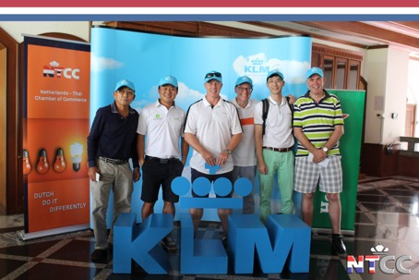
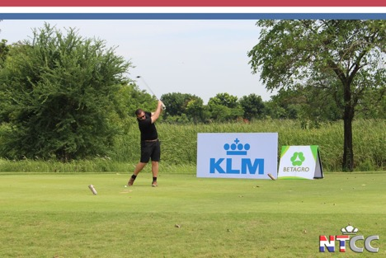
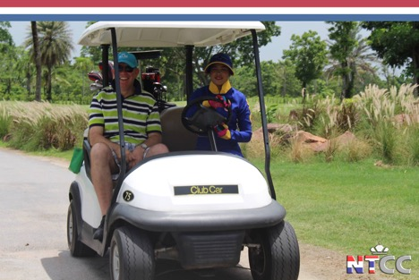
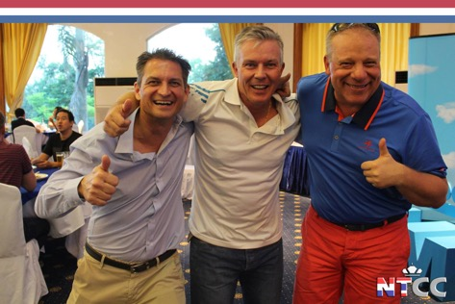

Target group 2018
- The 300 NTCC-member companies.
- Expats and International Thais established in Bangkok.
- 160 participants from 40 teams.

Opportunity
- Support a charity foundation
- An affordable way to achieve brand awareness at and after the event.
- Gain exposure within the expat and international Thai community.
- Show support for the two communities.
- Network at the event with companies from within the NTCC members.

The Club House F&B station (THB 25.000)
- Set up your stand, welcome all 160 players, as soon as they enter the venue, and be part of their first impression! (10.30 – 12.00 hrs)
- Stick around for the cocktail party for even more exposure (17.30-18.30 hrs).
- Set up your own banners and flag within the surroundings of the stand.

________________________________________
The ‘Hole in one’ F&B Kiosk (THB 20.000)
- Set up and promote your newest F&B items at one of our kiosks, situated at key locations of the golf course.
- There will be players circulating the area at all times, having a seat and enjoying the F&B provided by your company (approx. 12:00-17:30 PM).
- Set up your own banners and flag within the surroundings of the kiosks.
_________________________________________
The Product Promotion ‘starter pack’ Kiosk
(THB 20.000)
- Set up and promote your newest products at one of our key locations!
- Your company could possibly create a mini-side game for the players that could potentially win one of your products as prizes.
- There will be players circulating the area at all times (12:00-17:30 PM).
- Set up your own banners and flags within the surroundings of the kiosks.

Kiosk
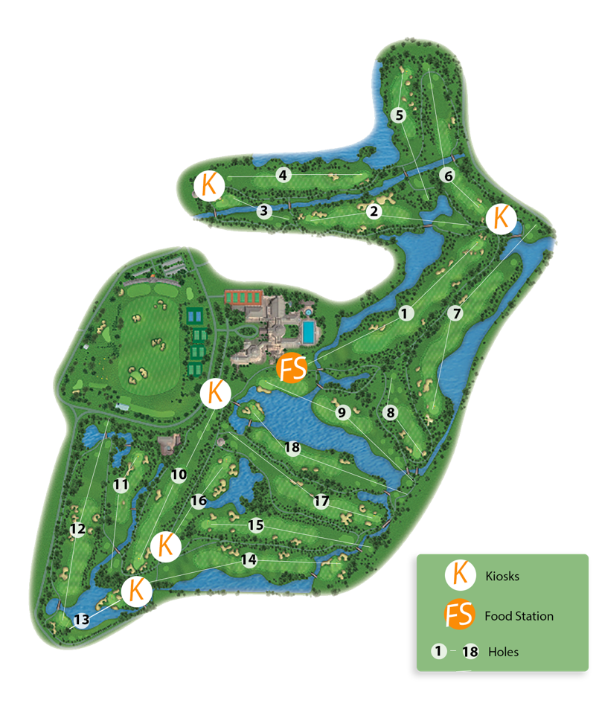
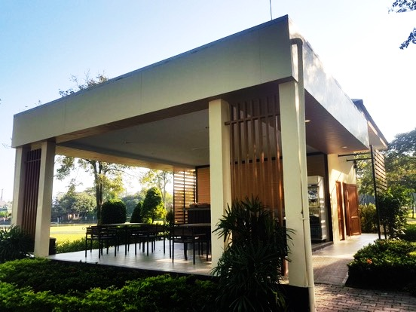
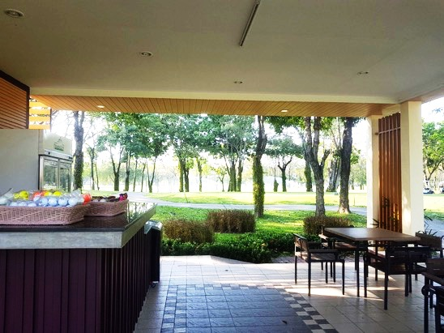

Booth Sponsorship Contract
NTCC - KLM Golf Tournament 2018
Please send this form to events@ntccthailand.org
Type of Package (Please select your choice below):
__The Club House F&B station (s)
(THB 25.000 / package) = THB __________
__The ‘Hole in One’ F&B (s)
(THB 20.000 / package) = THB ___________
__The Product Promotion ‘starter pack’ (s)
(THB 20.000 / package) = THB ___________

Total = THB ___________
Sponsor details
Company: ______________________________________________
Contact Person: ________________________________________
E-mail: ________________________________________________
Tel.: __________________________________________________

Date: _______________________ Signature: _________________

