Event Sponsor Packages

The Netherlands – Thai Chamber of Commerce proudly presents the upcoming “KLM – NTCC Golf Tournament” on the 5th of April 2018, at the Thana City Golf & Country Club. The annual sportive event that brings NTCC members together to network and have a fun day out.
The tournament will start with a registration at 10.30 hrs. and shotgun at 12.00 hrs., followed by a cocktail reception, celebratory dinner and awarding ceremony with nine prestigious cups presented at the evening. Golfers can enjoy great entertainments and have an opportunity to win the various lucky draw prizes.
With the success of 2017, we expect this year’s event to be a full-house of 160 participants from 40 teams within the NTCC 300-member companies.
A part of the tournament’s proceed will also be donated to a charity foundation and your support as the event sponsor would be very much appreciated. For more details regarding the sponsorship, please refer to the attached files.
Thank you so much for your kind consideration and should you have any inquiries regarding the tournament, please contact Ms. Papatsorn Krunggratoke via events@ntccthailand.org or tel. +66 2 254 6434 from Monday – Friday, 08.00 – 17.00 hrs.

Sincerely,
Hans van den Born
Executive Director

Last Year Event
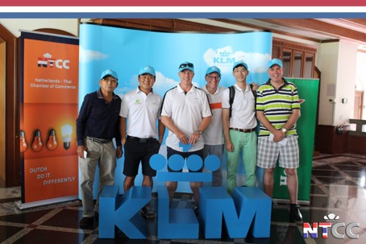
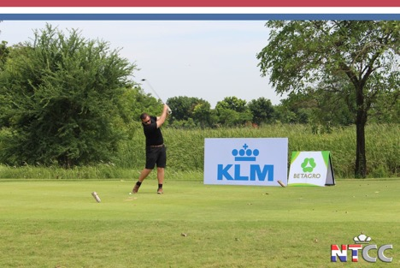
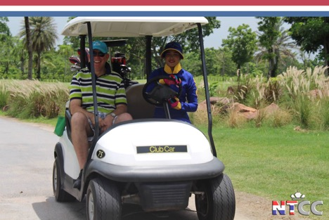
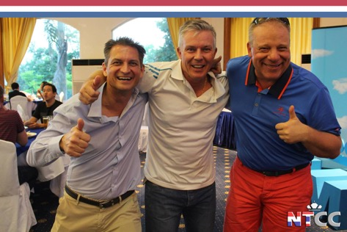

Target group 2018
- The 300 NTCC-member companies.
- Expats and International Thais established in Bangkok.
- 160 participants from 40 teams.

Opportunity
- Support a charity foundation
- An affordable way to achieve brand awareness at and after the event.
- Gain exposure within the expat and international Thai community.
- Show support for the two communities.
- Network at the event with companies from within the NTCC members.

The Eagle package
42,000
THB
- Logo on e-mail banner
- Logo on sponsor wall
- Logo on digital poster of event
- Mention in welcome speech
- Logo on projected screen in the dining area
- 1 team- 4 players

Aftercare program
- Pictures on social media from the event with logo in the background
- Logo and mention in the post attendance thank you letter to participants
- Logo published in premium position on special sponsor page in the NTCC Commerce Magazine.

35,000
THB
The Birdie package
- Logo on e-mail banner
- Logo on sponsor wall
- Logo on digital poster of event
- 1 team- 4 players

Event Sponsorship Contract

NTCC - KLM Golf Tournament 2018
Please send this form to events@ntccthailand.org
Type of Package (Please select your choice below):
___The Eagle package(s) (THB 42.000 / package) = THB ___________
___The Birdie package(s) (THB 35.000 / package) = THB ___________

Total = THB ___________
Sponsor details
Company:______________________________________________
Contact Person: ________________________________________
E-mail: ________________________________________________
Tel.: __________________________________________________

Date: _______________________ Signature: _________________

