Event Sponsor Packages

The Netherlands – Thai Chamber of Commerce proudly presents the upcoming “KLM – NTCC Golf Tournament” on the 5th of April 2018, at the Thana City Golf & Country Club. The annual sportive event that brings NTCC members together to network and have a fun day out.
The tournament will start with a registration at 10.30 hrs. and shotgun at 12.00 hrs., followed by a cocktail reception, celebratory dinner and awarding ceremony with nine prestigious cups presented at the evening. Golfers can enjoy great entertainments and have an opportunity to win the various lucky draw prizes.
With the success of 2017, we expect this year’s event to be a full-house of 160 participants from 40 teams within the NTCC 300-member companies.
A part of the tournament’s proceed will also be donated to a charity foundation and your support as the event sponsor would be very much appreciated. For more details regarding the sponsorship, please refer to the attached files.
Thank you so much for your kind consideration and should you have any inquiries regarding the tournament, please contact Ms. Papatsorn Krunggratoke via e-mail address: events@ntccthailand.org or tel. +66 2 254 6434 from Monday – Friday, 08.00 – 17.00 hrs.

Sincerely,
Hans van den Born
Executive Director
Last Year Event
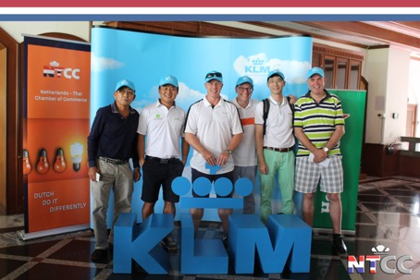
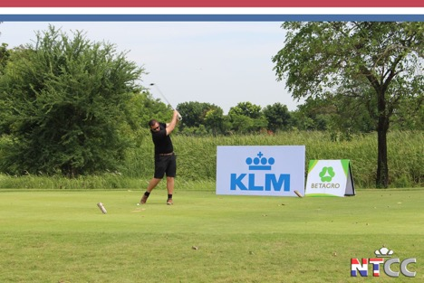
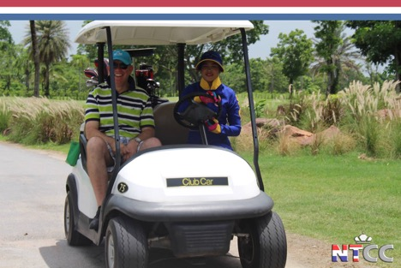
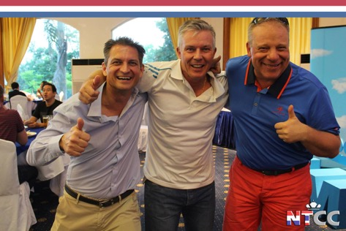

Target group 2018
- The 300 NTCC-member companies.
- Expats and International Thais established in Bangkok.
- 160 Participants from 40 teams.

Opportunity
- Support a charity foundation.
- An affordable way to achieve brand awareness at and after the event.
- Gain exposure within the expat and international Thai community.
- Show support for the two communities.
- Network at the event with companies from within the NTCC members.

In-kind Sponsorship

NTCC - KLM Golf Tournament 2018
Please send this form to events@ntccthailand.org

Please select your in-kind sponsorship types and specify the item(s) below:

Item(s) offered:________________________________________________

Value: __________ THB
Sponsor details
Company: ______________________________________________
Contact Person: ________________________________________
E-mail: ________________________________________________
Tel.: __________________________________________________

Date: _______________________ Signature: _________________

