COFFEE CHAT VIRTUAL WEBINAR
Marine Tech Opportunities in Indonesia, Thailand, and
Singapore
AGENDA
Introduction and Upcoming Programs | Maryanne Burke  ITA Marine Technology Team Leader
Regional Overview | Officer Charles Phillips  Regional Snr. Commercial Officer
Indonesia Overview/  Marine Tech Briefing | Specialist 1  Mario Simanjuntak Marine Technology Commercial Specialist
Singapore Overview/  Marine Tech Briefing | Specialist 2  Marine Technology Commercial Specialist
Thailand Overview/  Marine Tech Briefing | Specialist 3  Marine Technology Commercial Specialist
Moderated Q&A | Maryanne Burke
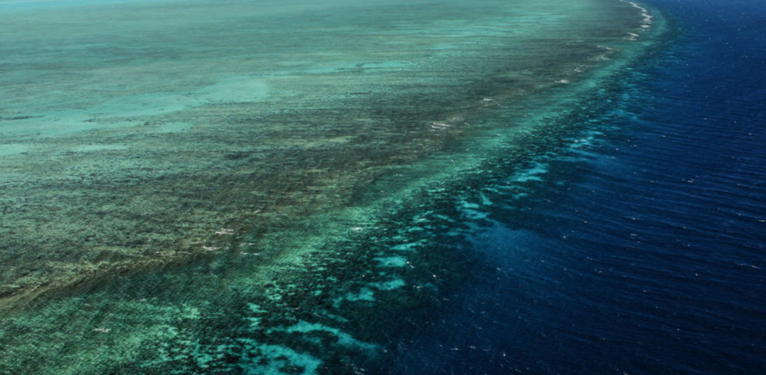
Join the U.S. Commercial Service (USCS) for a virtual coffee that with U.S. Embassy Marine Technology Specialists from Indonesia, Thailand, and Singapore. This informal video discussion will cover the marine technology sector in Indonesia, Thailand, and Singapore, and include a brief regional overview and Q&A session.
August 4, 2021|9PM Eastern Time
Microsoft Teams| Complimentary
Indonesia, Thailand, and Singapore are large markets for marine tech in the ASEAN region. Singapore is home to more than 5,000 maritime organizations and businesses. Singapore has the most utilized shipping hub in the Asia-Pacific region. Thailand has the 4th largest port in the ASEAN region 22nd in the world, Laem Chabang Port, and primary sectors include port development, shipbuilding and repairing leisure boats. Marine tech sector in Indonesia from supports approximately 7.86% to the economy. Marine markets such as fisheries, marine industry, marine infrastructure and marine services are key sectors that contain potential to be developed.

PROGRAM DETAILS
DATE: Wednesday, August 4, 2021
TIME: 9PM Eastern Time
LOCATION: Microsoft Teams- Webinar
COST: Complimentary
QUESTIONS: Maryanne Burke, USCS, at Maryanne.Burke@trade.gov
Register Now
WHY ASIA’S MT & ET SECTORS
U.S. Department of Commerce | International Trade Administration | U.S. Commercial Service
Export.gov

